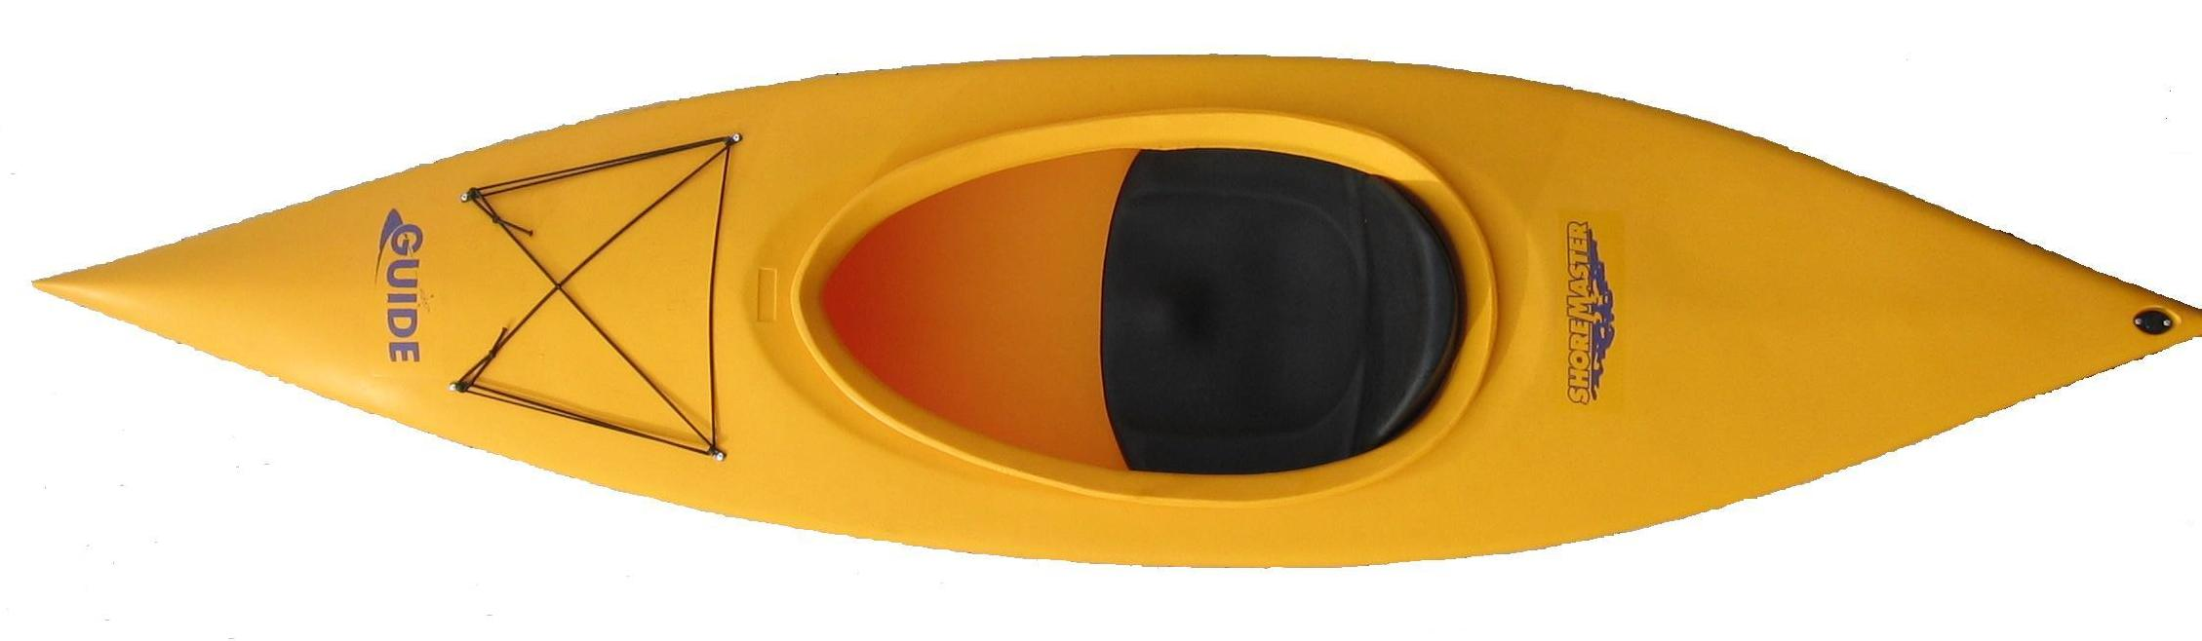

ShoreMaster Guide Kayak

The Guide is perfect for cruising everywhere from winding rivers to glacial lakes. Small and lightweight enough to launch alone, this stable craft is designed for easy use by anyone age 5 to 95.

Solid Dependable Hull made of HDPE Polyethylene
Rear Drain Plug
Deck rigging
Deep Bucket seat

Width | 27”
Length | 10’
Weight | 40lbs
Capacity | 220lbs
Cockpit size | 35” x 18”
Colors | Orange, Olive and Yellow

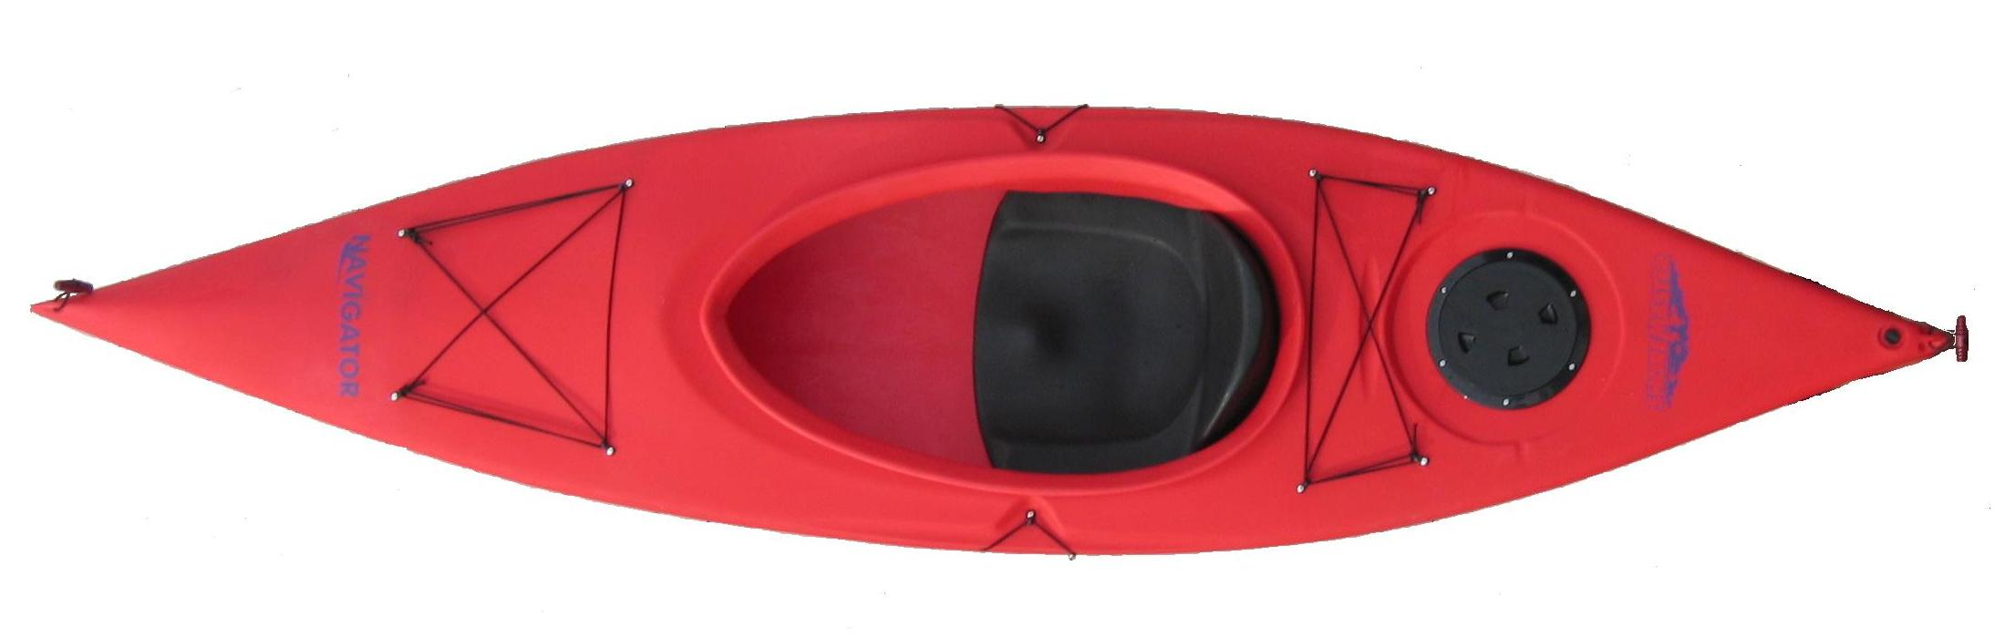

ShoreMaster Navigator Kayak

Whether you’re just out for some exercise, cruising the nearest pond or exploring the habitat of your favorite waterfowl-the Navigator is the perfect craft to do it in. It’s lightweight and stable enough to keep newer paddlers confident while more advanced paddlers will appreciate its maneuverability and comfortable high back seat.

Solid Dependable Hull made of HDPE Polyethylene
Water tight stern hatch with removable storage bag
Rear Drain Plug
Front and rear handles
Front and rear deck rigging
Paddle holder
Deep Bucket seat

Width | 27”
Length | 10’
Weight | 42lbs
Capacity | 220lbs
Cockpit size | 35” x 18”
Colors | Sand, Red and Green

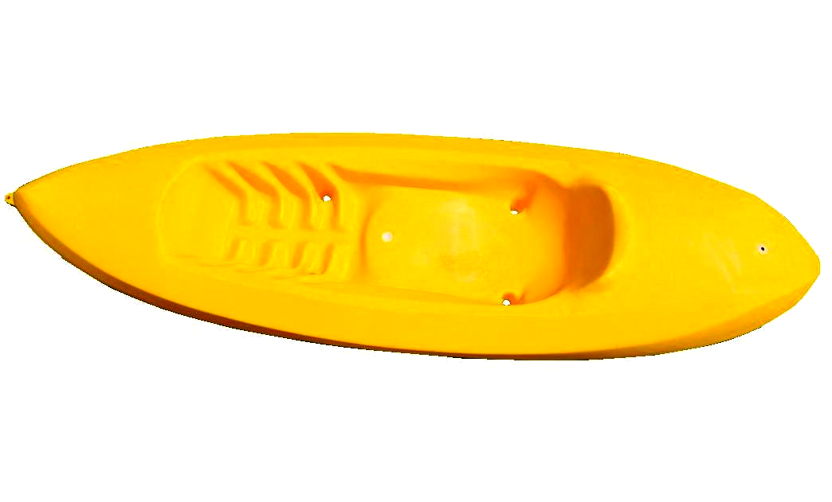

ShoreMaster Scout Kayak

So you’ve only got a day to get away from it all? The Scout Kayak is an excellent companion. It’s perfect for short runs down small rivers, or cruising the water searching for hidden coves, sandy swimming beaches or new fishing holes. It handles excellently, and its super stable demeanor gives you the confidence to scout out new territories. The Scout Kayak is the perfect choice for everyone from the beginning paddler, to the experienced paddle-sport enthusiast.

The Scout’s sit-on style allows you stable maneuverability and a molded keel for straight tracking.
The molded seat of the Scout Kayak provides a comfortable ride all day.

Outside Width | 27”
Outside Length | 8.5’
Weight | 40lbs
Capacity | 220lbs
Interior size | 16” x 53”
Colors | Yellow, Orange and Red

